Linux memory management

- Introduction
Virtual address, page, page table are the basics of the modern os. Virtual memory let user program think they own the whole address space .
- Concept
- Virtual memory
Why use virtual memory
- Virtual memory is a way to extended system RAM by using extra, slower, system secondary memory. That is, once system memory is run out of, system will swap some memory onto hard disk, and free some main memory space.
- Virtual memory is an abstraction between the address space and the read physical memory available in the system. This means that when a program uses an address, that address does not refer to the bits in an actual physical location in memory. all addresses a program uses are virtual.
- Virtual memory let user program own the whole address space.

- Pages ---virtual memory
- The total address space is divided into individual pages.
- Pages can be many different sizes, usually around 4kiB
- Each page have a number of attributes set by os. These include read, write, exe permissions for the page. For example, mark code page an exe flag, and processor can choose to not exe any code from page without this bit set.

- Physical memory
- OS divides the available physical memory up into frames,
- Is the same size as the system page size
- The os keeps a frame-table which is a list of all possible pages of physical memory and if they are free (available for allocation) or not. When memory is allocated to a process, it is marked as used in the frame-table.
- How does the operating system know what memory is available? This information about where memory is located, how much, attributes and so forth is passed to the operating system by the BIOS during initialization.

- Pages → page frames ----page tables
- page-table keep the info that virtual-page points to physical frame.
- It can be simplest form, each page correspond to a page frame, that is, a linear page table. For 32-bit addps[ace and 4kiB pages, there will be 2^20 possible pages to keep track of in the page table, so there will be 2^20 entries long to ensure we can map a virtual page to a physical page for the whole memory space.
- When a process requests memory, the operating system finds it a free page of physical memory and records the virtual-to-physical translation in the processes page table. Conversely, when the process gives up memory, the virtual-to-physical record is removed and the underlying frame becomes free for allocation to another process.

- Virtual address
- consists of two parts; the page and an offset into that page.
- Virtual address is what program use to access memory. And operating system and hardware work together to map and locate the right physical address
- Page
The smallest amount of memory that the operating system or hardware deals with is a page
- Offset
The last 12 bits of the virtual address are called the offset which is the location difference between the byte address you want and the start of the page.
each of these 4096 bytes reside within a single page and are dealt with as "one".
- Virtual address translation
- It is a process of translating a virtual address to a physical address
- The essence of the procedure is to take the page number of the given virtual address as an index and look it up in the page-table to find out the physical page frame, then add the offset from the virtual address to give the actual location in the physical memory.
- Detail virtual address translation process
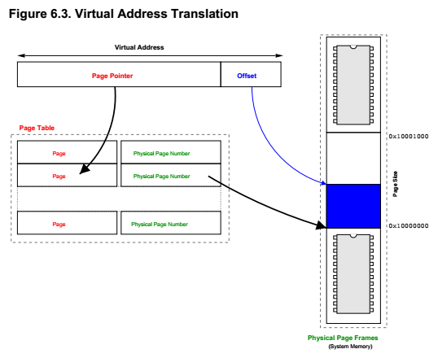
- Example of a simple linear page-table
For a 32bit address space and 4KiB page, require a table of 2^20 entries. A virtual address of 0x80001234, The first step is remove the offset bit, just right shift 12 bit of the address, the result is 0x80001. Thus the value of the 524289th entry of the linear page table would be the physical page frame corresponding this page.
- For the issue of the linear page table, every page must be accounted for, it’s impractical with a 64bit address space. There will be 2^52 entries to record, and each page need an 8B pointer for a physical page. It will need 2^55GiB
- others
- Consequences of virtual addresses, pages and page tables
- Individual address space
Each process has its own page table. So two process might use the same address, as different page tables for each process will map it to different physical address. So os provide each process with its own address space.
Over time, there will be holes of free space in the physical memory, namely physical memory becomes fragmented.

- Protection
Virtual memory provide protection for the process running on it. For system without virtual memory, every process have complete access right to all the system memory. This means one process can overwrite another process memory, causing the system to crash.

\ For system with virtual memory, each process has its own page table, If a process gives a virtual address that is not covered by its page-table, then the operating system knows that that process is doing something wrong and can inform the process it has stepped out of its bounds.

Since each page has extra attributes, a page can be set read only, write only or have any number of other interesting properties. When the process tries to access the page, the operating system can check if it has sufficient permissions and stop it if it does not.

Systems that use virtual memory are inherently more stable because, assuming the perfect operating system, a process can only crash itself and not the entire system.
- Swap
Swap memory is a memory pointing to a area of memory which will swap to the disk.
When this page is referenced, the operating system needs to move it from the disk back into system memory. When the system memory use up, then another page need to be kicked out of the system memory and put into swap disk to release freee memory.
- Mmap
A different but related process
instead of the page table pointing to physical memory or swap the page table points to a file
the file is mmaped
you need to open a file on disk to obtain a file descriptor, and then read and write it in a sequential form. When a file is mmaped it can be accessed just like
system RAM
- Shared memory
each process gets its own page table, any address is mapped to a unique page frame in physical memory. If two page table entries points to the same frame, this means that this frame will be shared. and any changes that one process makes will be visible to the other.
For example of how threads are implemented. Clone() func could share as much of a new process with the old process. It a process call clone to creat a new process , and require that the two processes share the same page table, then a thread see the same physical memory.
For example of copy on write. If a cloned process tries to write to the page, the os will know this page is a copy on write page, then it need to make a new copy of this page in memory and points the page in page table to the new page. Then updata its attributes to have write permissions. So the process has its own copy of the page
- Page cache
The page cache refers to a list of pages the kernel keeps that refer to files on disk. From above, swap page, mmaped pages and disk cache pages all fall into this category.
The kernel keeps this list because it needs to be able to look them up quickly in response to read and write requests
- TLB
- Translation Lookaside Buffer
- It is a cache of virtual-page to physical-frame translations inside the processor.
- Page Faults

- Finding the page table
- Other page related faults
- Others
- others

